Useful Excel Functions for Business

Microsoft Excel is one of the most commonly used programs in the world. Regardless of what field you are in, having a strong background in excel will make you a valuable asset. This lesson will teach you functions that have been the most useful to me in my professional life. These functions include VLOOKUP, Pivot Tables, and some other keyboard shortcuts that make everything easier.

- The first thing to do when working in excel is to name your sheet. Click on the tab in the bottom left corner and name the sheet appropriately.

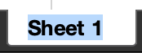

To practice, we will use a scenario based on our class.

Name the first sheet “Homework”.

- Create 5 Columns (In this Order)
  - Name
  - Homework 1,2,3
  - Average

- In the name column, list the names of all the students in the class.
- In the second column we will use the RANDBETWEEN function. This function generates random numbers between numbers that you specify.
- Anytime you want to enter a formula in excel you must type an equal sign “=”. 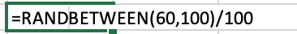

- Use the fill handle in the bottom right of the cell (Notice the cursor symbol change) to drag this formula across all homework cells.

- Highlight all of the cells with this formula and copy them. We will then go to paste special in the upper left corner. This allows us to paste just the values.

- In our Average column, we will now use the average function in cell F2 and highlight the three highlight grades (B2:E5). Double click the fill handle to apply it to all cells. Individuals.

- Highlight all cells we have used (A1:F12) and under the insert tab click “Table” (Make sure my table has headers is checked).

- Highlight all the cells by clicking the symbol between Row A and Column 1. Right click the cells and under number format select “Percentages” and scroll to two decimal places.

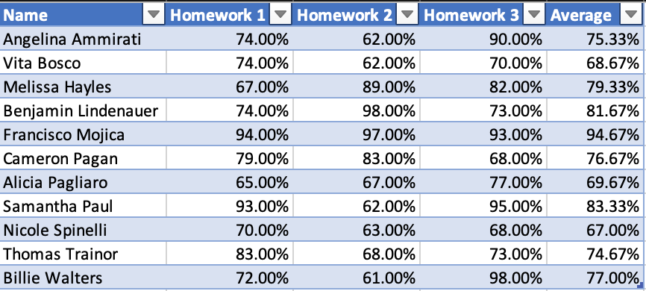

- Repeat the first 9 steps except label anything homework with exam instead.

- We will change the Tab colors. Right click the sheet and choose two different colors for each sheet.

- Create a Third sheet called “Final Grades”. Copy and paste the previously used names columns. Then create a new column called group. Label the first four students Team A, the next 4 Team B, and the last three team B.

- Create two new columns called “Homework Average” and “Test Average”, respectively. Then enter the VLOOKUP function in cell C2. This function requires four elements.

  - Lookup Value: The identifying factor that both groups have in common, in this case name.
  - Table Array: The table in which the value we are looking for is located.
  - Column Index Number: The column in the table array in which the value is located.
  - True or False: True for an approximate match on the lookup value. False for an exact match. False will be used most of the time.
- Use the fill handle to fill in the values and repeat the step in the homework column.
- Create a column called final grade and a column called letter grade. Determine final grade using a weighted average. Weigh the tests as 70% and the homework as 30%.

- Use the Vlookup Function with the table that was provided to determine letter grades. Create a table on this page.

- Under insert, insert a pivot table under a new sheet. Name this sheet group performance. Under the rows section, drag down group and then letter grades (order matters). Drag final grades to the sum of values section and right click to change the value to count.

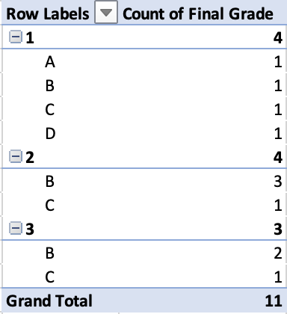

- Test some different variables in the table and see what you come up with.

